Reading Guide for: Ancient Civilizations Unit
Includes reading for: Africa (2.1, 2.2 & 12.1), Ancient India (3.1-3.2 & 4.1-4.3), Ancient China (3.3, 4.4-4.5) and the Fertile Crescent (2.3-2.5)

Date | Topic For Class | HW for this night | What to look for while reading
8/23 | Intro Day | None | Read Syllabus, ask questions about it tomorrow.
8/24 | Great (Wo)man Theory | None | Complete intro activity and reflect on historically what we think makes a man “Great”.
8/25 | Historical  Theories |  | Students will create a poster based off the historical theories presented to them within class.
8/26 | QFT Egypt | None | As students complete the QFT, have them reflect on the experience of generating questions.
8/30 | Key features of a civilization for Egypt | World History Textbook 12.1 (280-281) and 2.1 | While reading 12.1 look for ways that geography affects the way people live in Africa. What would cause people to move from a nomadic to sedentary lifestyle (know those words.) 2.1 focuses on what are the main characteristics of each period (old, Middle, New). Look for what type of govt., key achievements, and reasons for decline and leaders
8/31 | Egypt Map Generalizations | None
9/1 | Egypt Old, Middle and New Kingdoms | World History Textbook 2.2 | No reading, study for Quiz
9/2 | “Book of the Dead” Primary Source Document Reading | World History Textbook 3.1 and 3.2 | How has geography influenced the region? What makes a place like Harappa and Mohenjo-Daro unique? In 3.2, focus on 55-57, what did the Aryans leave behind that is now an important part of Indian culture?
9/5 | No School Labor Day
9/6 | Features of Civilization for India  Aryan Civilization | World History Textbook 4.1 and 4.3 | In 4.1, only read section on Hinduism; will come to Buddhism later. Read all of 4.3. I would create a concept map, organizing similar to the graphic below.  4  Hinduism  1.  2  3  Goal, 2. Karma and Dharma, 3. Caste, 4. Beliefs
9/7 | Hinduism | Mahabharata/ Ramayana Readings | As you read, look for examples of Hinduism in the readings. Use the questions as a guide to reading
9/8 | Hinduism | World History Textbook 4.1 | Only focus on the Buddhism section of 4.1. I would make a Venn diagram comparing Buddhism and Hinduism in order to best understand the two ideas.
9/9 | Buddhism | World History Textbook 4.2 | Once again, I would create a Venn Diagram that compares the Maurya and Gupta Empires. Create categories for each section of the Venn. Ask me in class on how to do this. (This allows me to know you are looking at this).
9/12 | Maurya & Gupta Empires | Study for India Quiz | Study for Quiz
9/13 | India Short Answer Assessment (In class writing) | World History Textbook 3.3 | Focus on 3 main ideas during the reading, culture, geography and achievements. Use those as major themes for your notes. You will take notes on specific dynasties tomorrow.
9/14 | Civilizations features of China. Dynastic Cycle and Mandate of Heaven | World History Textbook 3.3 and 4.5 | While reading, create your own dynastic cycles for the Shang, Zhou, Qin and Han dynasties. Under Period of prosperity, write what the accomplishments of each period were.
9/15 | Dynastic Cycles of Ancient China | World History Textbook 4.4 | Key questions/ideas to focus on in 4.4: What are the key components of each philosophy? What is the main purpose of each of these philosophies in Ancient China? Which one do you think would be more effective and why?
9/16 | Chinese Philosophies | Complete handbook | N/A
9/19 | Chinese Philosophies | TBD | N/A
9/20 | Chinese Philosophies DBQ | World History Textbook 2.3 | How has the geography of the Fertile Crescent affected how Sumerian society is set up? What are some of the major accomplishments of the Sumerians? Compare and contrast to the Egyptians.
9/21 | Fertile Crescent  Epic of Gilgamesh | Fertile Crescent Chart | Create a chart with the following groups: Sumer, Akkad, Babylon, Hittites, Assyria and Persia. Categories should include location, government, religion, key contributions.
9/22 | Code of Hammurabi discussion/ Fertile Crescent Empires | World History Textbook 2.5 | We have already discussed religion this year, so I would focus on the same concepts of how it was founded, key figures, key beliefs, and other key attributes of the religion.
9/23 | Judaism | Study for map quiz | Study for map quiz.  At this time, I would also begin creating a study guide for your unit test on Ancient Civilizations. I will help you create this, please ask in class.
9/26 | Catch up/Review | Study for Unit Test | Create Study Guide
9/27 | Ancient Civilization Test | World History Textbook 5.1 | Look at new reading guide for Guide to Reading

Great (Wo)Man Theory Use the following link to access the video. https://goo.gl/OxQSjm

Before watching the video
What do you think people have done throughout history to earn the title ‘THE GREAT’?

While watching the video, listen for answer to these questions:
1. What are the 2 problems Mr. Green identifies with calling someone ‘THE GREAT’?

2. What are the 3 ways we decide to call someone ‘THE GREAT’?

3. At the end of the video, Mr. Green suggests there is a 4th way to determine ‘GREATNESS.’ What is it?

After watching the video
1. Use information from the video to summarize what the Great Man theory is

2. Finally, a key idea of this video is that we decide history, what to care about and who is great. He suggests that we made Alexander, Alexander the Great. Who are we making ‘GREAT’ and briefly explain whether you are happy with whom we are making great today?

Historical Theories - What are the causes or forces of change in history?
THEORY | DESCRIPTION | IN 3-5 WORDS | MAKES ME THINK OF… | IN PICTURE FORM
Economic Determinism | - History is the story of class struggle, or the fight to control wealth.  - Certain stages of struggle for example are: slavery, landlords vs peasants, factory owners vs workers.  - According to Karl Marx, eventually the weaker groups unite and overthrow the wealthy, powerful few.  - For Marx, the end point or goal of history would be a classless society known as communism.
Theological Determinism | - Events that happen in life are pre-determined by God.  - Some debate whether humans possess ‘free will’ and then God forgives OR whether God controls all actions, decisions in life. The idea of the latter or predestination is credited to John Calvin.  - Followers of Judaism, Christianity and Islam are believers.
Geographic Determinism | - The environment and geography are the greatest factors that explain the rise and fall of cultures.  - Varying global climates have allowed for the development or specific, diverse cultures and natural occurrences such as drought explain their decline.  - People with environments more favorable to farming plants and animals have become the most powerful in history.
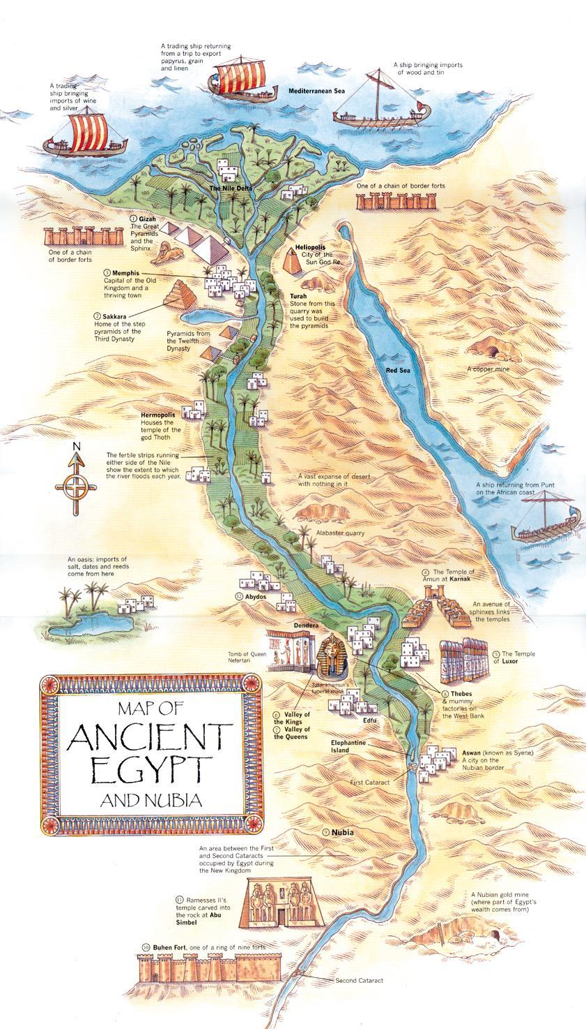
Features of a Civilization

A selection from the Book of the Dead

Egyptians believed that after death, a person had to justify himself or herself before a tribunal of the underworld headed by Osiris. The deceased would assure the judges through a “negative confession” that he or she had not committed certain crimes. Texts for these confessions were written on papyrus and placed in the grave of the dead person. A large number of such texts have been collected by modern scholars and are known as the
Book of the Dead.

Read the selection from the collection below and then answer the questions that follow.
What do Egyptians value? Underline examples of this and make a list in this box of what is most important to Egyptians based off the reading.
Hail to you, great God, Lord of Justice! I have come to you, my lord, that you may bring me so that I may see your beauty, for I know you and I know your name, and I know the names of the forty-two gods of those who are with you in this Hall of Justice, who live on those who cherish evil and who gulp down their blood on that day of the reckoning of characters in the presence of Wennefer. Behold the double son of the Songstresses; Lord of Truth is your name. Behold I have come to you, I have brought you truth, I have repelled falsehood for you.
I have not done falsehood against men, I have not impoverished my associates, I have done no wrong in the Place of Truth, I have not learnt that which is not, I have done no evil, I have not daily made labor in excess of what was to be done for me, my name has not reached the offices of those who control slaves, I have not deprived the orphan of his property, I have not done what the gods detest, I have not slandered a servant to his master, I have not caused pain, I have not made hungry, I have not made to weep, I have not killed, I have not turned anyone over to a killer, I have not caused anyone’s suffering, I have not diminished the food-offerings in the temples, I have not debased the offering cakes of the gods.
I have not taken the cakes of the blessed, I have not copulated illicitly, I have not been unchaste, I have not increased nor diminished the measure, I have not diminished the palm, I have not encroached upon fields, I have not added to the balance weights, I have not tempered with the plumb bob of the balance. I have not taken milk from a child’s mouth, I have not driven small cattle from their herbage, I have not snared birds for the gods’ harpoon barbs, I have not caught fish of their lagoons, I have not stopped the flow of water in its seasons. I have not built a dam against flowing water; I have not quenched a fire in its time. I have not failed to observe the days for haunches of meat. I have not kept cattle away from the God’s property; I have not blocked the God at his processions.
I am Pure. I am pure. I am pure. I am pure. My purity is the purity of this great Phoenix that is in Heracleopolis, because I am indeed the nose of the Lord of Wind who made all men live on that day of completing the Sacred Eye in Heliopolis in the 2nd month of winter last day, in the presence of the lord of this land. I am he who saw the completion of the Sacred Eye in Heliopolis, and nothing evil shall come into being against me in this land in this Hall of Justice, because I know the names of these gods who are in it.
What is the main idea that the selection is trying to portray? What does this say about Egyptian culture?

Hinduism

Hinduism is not a unified, coherent religion, but rather a collection of many related religious beliefs and practices that are accepted within the framework of Hindu society. Having evolved for more than 3,000 years, Hinduism embraces an extraordinarily complex system of rituals, cults, institutions, practices, and doctrines. A Hindu may be a monotheist, polytheist, or atheist. Hindus may attend temple, follow strict standards of conduct, or practice religious rituals, but none are requirements. Hinduism's wide religious umbrella includes everything from animal worship to mysticism to profound theological doctrines.
There is no single scripture as in Christianity's Bible, but rather thousands of collections of writings and teachings. Although most Hindus believe in gods, there is no single explanation for who or what the gods are. In fact, there are believed to be more than a million gods in Hinduism. "Hindu" is a catch-all term that includes most of the thousands of different religious groups that have evolved in India since 1500 BCE.
The word "Hindu" comes from the Persian word "Hind," the term used to describe the region around the Indus River in northern India. Civilization flourished in that region starting in about 2500 BCE. Around 1500 BCE, migrating groups of people from Central Asia passed through the Himalayas and settled in India. Known as Aryans, they were fair-skinned and came to dominate the Indian subcontinent for the next thousand years through a network of village communities. They developed a form of social organization known as caste and used the Sanskrit language.
With little or no opposition, Hinduism developed its basic patterns, including spiritual practices, forms of worship, and religious concepts. In addition, many of the Hindu texts were written during that period. Because there was no central authority, however, Hinduism developed a mix of beliefs and practices. Many communities came to believe in their own gods and followed very localized beliefs, a trait that continues to the present.
Contact with outside societies led to the spread of Hinduism beyond local limits and the widespread influence of the religion. Several sects had followings throughout India, including the Vaishnavites, Shaivites, and Shaktites. The Brahmin caste's status rose significantly during that era as well. Hinduism spread even farther during the Gupta Empire (fourth to sixth centuries CE) to southeastern Asia and Indonesia.
Unchallenged by outside influences and gaining further dominance over Buddhism, Hinduism continued to evolve in India for the next several centuries. That dominance came to an end in the early 11th century, when the Muslim Mahmud of Ghazna invaded northwestern India and introduced the powerful influence of Islam to the subcontinent. Islamic rulers established the Delhi sultanate, a single administrative center for northern and central India headquartered in Delhi.
Muslim leaders took different approaches to Hinduism. While some tolerated the local religions, others persecuted Hindus and destroyed Hindu temples. Muslim control, however, did not arrest the development of Hinduism. In many cases, attempts were made to merge elements of the two religions into new faiths, like Sikhism.
Two categories of Hindu scriptures are sruti and smrti. Sruti literally means "hearing." It is the term used for texts that describe eternal knowledge as revealed to Hindu seers (rishis). Those revelations have been passed down through the generations by Brahmin priests. The most important sruti texts include the Vedas, the Brahmins, the Upanishads, and the Aranyakas. Smrti refers to traditional, or "remembered," knowledge. Those texts include the Epics, the Code of Manu, and the Puranas.
Hindus believe in a process of reincarnation known as samsara. Samsara is a perpetual series of rebirths in which a soul takes on any form of life (vegetable, animal, or human) in each birth. The process has no beginning and for most individuals, no end. Karma determines the form in which an individual is reborn. A person's karma is determined by his or her conduct in life; every action and thought in a present life dictates what form that person will take in his or her next life. Thus, Hindus believe that a person's fate is determined not by good or bad luck, but rather by the good or bad deeds of past lives. That concept helps justify the Hindu caste system, which grants each person a status according to his or her birth.
The Hindu caste system is the religion's most distinctive quality. This social stratification of society based on birth is called varna, which literally means "color." The system is very complicated but in its most general form consists of four major social categories: Brahmin, Kshatriya, Vaishya, and Sudra. Another class, the "untouchables," falls outside the system. In the traditional system, Brahmins are the highest rank and act as the priests and spiritual and intellectual leaders of Hindu society. Next are the Kshatriya, the rulers and warriors who protect and promote the material well-being of society. The farmers, merchants, and others who contribute to the economy are the Vaishya, while the Sudra are the workers and servants who supply the menial labor for the upper three ranks. The fifth category, the untouchables, emerged over time. They were excluded from all rituals and in some parts of India, were banned from public. Moreover, they often had to identify themselves as untouchables so those of higher rank could avoid being near them.
There are thousands of different Hindu sects. The majority of those sects are folk versions of Hinduism. The lower castes often restrict their religious practices to deities that exist in trees, water, and other natural elements. They frequently turn to astrology and occult practices. Ritual purification, charms, and traditional local customs play a far more significant role in their lives than doctrine. Black magic, exorcism, the worship of snakes, and ritual nudity are all elements of the many different brands of folk Hinduism that can be found throughout India (particularly in rural India). Journeys to such sacred places as temples, Harwar in the Himalayas, the Bay of Bengal, and the Ganges, the most holy of rivers, also play a major role in folk Hinduism. Though not limited to folk Hinduism, the worship of cows is another significant part of a Hindu's life.
In their array of gods, three stand out for millions of Hindus. Collectively, they are known as the Trimurti, the three deities who represent absolute reality. Shiva is known as "the Destroyer" and has a complex, seemingly paradoxical character. Shiva is the god of death and destruction but also the god of reproduction and dance. His dichotomous character, which is also described as ceaselessly active and eternally restful, is considered to represent two aspects of one nature. The followers of Shiva are known as Shaivites. The second of those gods is Vishnu, "the Preserver." He is a humane god of benevolence and love. Vishnu has appeared on earth nine times to help preserve and restore humanity. Followers believe he will appear one last time to bring the world to an end. His previous appearances have included embodiments of Krishna and the Buddha. Adherents to Vishnu are generally monotheistic. The third god, which is the oldest and least popular of the three, is Brahma, "the Creator," from which both society and nature were derived.
Hinduism places emphasis on ritual observance. All the knowledge in the world and the practice of good deeds do no good without proper observance of Hindu ceremonies. The list of practices, like the number of different sects, is almost limitless. Nevertheless, some broad generalizations can be made.
For instance, ritual purification plays a major role in Hindu life. Only those who cleanse themselves are eligible to achieve absolute knowledge. There are two kinds of physical purity, internal and external. They can be achieved through washing, bathing, and the natural functions of the body. Yoga exercises, certain formulas, and purification acts can all contribute to a person's internal purity. Devotional services are supposed to be observed every day for gods, ancestors, seers, animals, and the poor.
In addition, hundreds of festivals are held to observe sacred occasions, including births, deaths, victories, and other significant events of Hindu heroes and gods. Many festivals are seasonal and may be observed through worship, the offering of gifts, drinking, games, fairs, chants, bathing, gambling, the lighting of lamps, and many other acts.
While thousands of tribal Hindu villages still perform rituals that have remained unchanged since ancient times, other Hindu communities adopt new beliefs and practices. That constant change, however, is itself something of a tradition for Hinduism.

MLA Citation
"Hinduism." World History: Ancient and Medieval Eras. ABC-CLIO, 2014. Web. 15 Sept. 2014.

Mahabharata
A STORY OF A WAR FOUGHT FOR A KINGDOM
The throne of the Kuru Tribe had fallen to a blind prince, who because of his affliction was barred by law from ruling. He therefore ceded the throne to his younger brother Pandu. The trouble begins when their sons reach maturity. By law the crown should next devolve to Yudhisthira, the eldest son of Pandu; but the blind man’s sons understandably wanted for themselves the kingdom that they might have had but for their father’s blindness. The eldest of the blind man’s sons, challenges Yudhisthira to a game of dice. The blind man’s son cheats and wins the kingdom for himself, but, subsequently persuaded to compromise, he agrees to return the throne to Yudhisthira after a period of 13 years.
The 13 years pass and Yudhisthira reclaims the throne, but his cousin has learned to like the taste of power and goes back on his promise. So Yudhisthira and his brothers go to war with their cousins, reluctantly, because they are peace loving men and their cousins have been life-long friends. In a bloody struggle that lasts 18 days, all of their cousins are killed. Yudhisthira and his brothers win the war and the kingdom, and Yudhisthira rules wisely into his old age.
In the middle of the account of the battle, the Mahabharata has a separate segment of some 700 couplets that stand alone as an independent religious treatise and work of art. This is the Bhagavad Gita, or lord’s song. It is so sacred Hindus that it is comparable to the New Testament in the Christian world, the Torah in the Jewish world and the Koran in the Muslim world. In this particular passage, Yudhisthira cries out to Krishna:

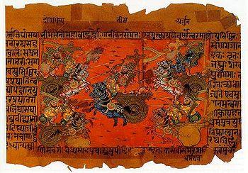
KRISHNA! AS I BEHOLD, COME HERE TO SHED
THEIR COMMON BLOOD, YOU CONCOURSE OF OUR KIN,
MY MEMBERS FAIL, MY TONGUE DRIES IN MY MOUTH…
IT IS NOT GOOD, O KRISHNA! NAUGHT OF GOOD
CAN SPRING FROM MUTUAL SLAUGHTER! LO, I HATE
TRIUMP AND DOMINATION, WEALTH AND EASE
THUS SADLY WON! ALSA, WHAT VICTORY
CAN BRING DELIGHT O KRISHNA, WHAT RICH SPOILS
COULD PROFIT, WHAT RULE RECOMPENSE, WHAT SPAN
OF LIFE ITSELF SEEM SWEET, BOUGHT WITH SUCH BLOOD?
KRISHNA ANSWERS:
“LET THEM PERISH, PRINCE, AND FIGHT!”

When Yudhisthira reaches the city of the gods after his death, he finds his vain and pompous cousin, whose greed had brought on the war, feasting happily among the gods. Then he is escorted on a tour of hell, where he endures the sight of his brothers and his wife burning in a pit. He cries out in anguish, only to hear from the gods that his cousin had earned his reward by fulfilling his dharma in going to war without quailing. Yudhisthira himself, for cursing the gods and questioning dharma, is condemned to a stint in hell and further rebirth, in order that he may better work out his dharma.

- Identify the rhetorical situation of the passage? What is the speaker, audience and purpose of the passage?

- What aspects of Hinduism are evident in the text? Please cite specific examples?

- Explain the role that dharma plays in the lives of Yudhisthira and his brothers by summarizing the text and the role it plays in Hindu culture.

Ramayana
The Ramayana begins as the tale of a golden age in the kingdom of Ayodhya, a time when,
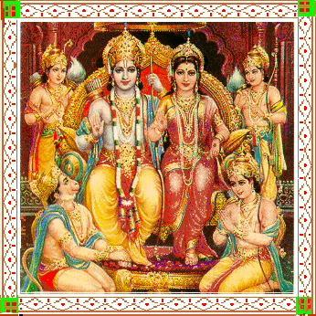
RICH IN ROYAL WORTH AND VALOR,
RICH IN HOLY VEDIC LORE,
DASCARTHA RULED HIS EMPIRE
IN THE HAPPY DAYS OF YORE…
PEACEFUL LIVED THE RIGHTEOUS PEOPLE,
RICH IN WEALTH, IN MERIT HIGH,
ENVY DWELT NOT IN THEIR BOSOMS,
AND THEIR ACCENTS SHAPED NO LIE.
FATHERS WITH THEIR HAPPY HOUSEHOLDS
OWNED THEIR CATTLE, CORN AND GOLD;
GALLING PENURY AND FAMINE
IN AYODHYA HAD NO HOLD.

But affairs take a sorry turn when the jealous stepmother of the crown prince Rama reminds the king that he once promised her any favor she might ask. She wants Rama exiled; she has a son of her own for whom she covets the throne. Though his kin and countrymen beg him to stay, Rama, without a word of reproach, prepares to set off. Such a prince, of course, must have a flawless wife, and Rama has one in Sita, a princess from a neighboring kingdom. She might have returned to her father’s palace, but instead she accompanies Rama into exile.
Rama and Sita go to live in a forest hut, where they lead an ascetic life- an existence that is held in high esteem by Hindus. Rama interrupts his meditations now and then to slay demons that abound in the woods, arousing the wrath of Ravana, the king of the demons. This evil creature, seeking revenge on Rama, steals into the prince’s hut one day, abducts Sita and carries her off to his castle, where he does all in his power to win her affection. He has no luck; the faithful Sita resists his lures and remains true to Rama.
Rama, meanwhile, has not been idle; with the help of the gods he has raised a band of fighting men and an army of sacred monkeys. After a long search, they come upon Ravana’s hideaway and rescue Sita. But finding his bride, Rama faces a dilemma. Being in love with her, he wants to take her back, but being bound by sacred law, he must cast her out for having lived under another man’s roof. Sita, understanding Rama’s dilemma, throws herself onto a funeral pyre. But because she is innocent, the fire-god Agni refuses to take her, and she comes of out the fire unscathed. With this proof of her virtue, Rama takes her back.
When Rama eventually re-inherits his rightful kingdom from his half-brother, who generously abdicates in his favor, his people receive his return with rejoicing. But after a time they begin to whisper about his wife. How can a woman who has dallied with another man properly reign as Rama’s queen? So Rama, whose first duty is to please his subjects, sadly decides for the second time to send her away- and sadly now no god like Agni comes to her defense. Rama rules without her for several years, then has a change of heart, and asks her back. But he has waited too long; Sita has been swallowed up by the earth of which she was born. Rama spends the rest of his days sad and alone, but a great hero for the noble spirit with which he executes his dharma.

- Identify the rhetorical situation of the passage? What is the speaker, audience and purpose of the passage?

- Cite examples of how the characters illustrate the concept of dharma?

- Draw a picture depicting the Ramayana.

Buddhism
Buddhism is one of the world's major religious traditions. Embraced by approximately 350 million people worldwide (most of them in Asia), Buddhism continues to exercise a strong influence in many areas. Like many of the world's religions, Buddhism began with the life of an extraordinary individual.
Life of the Buddha
Historians estimate that the founder of Buddhism, Siddhartha Gautama (one of many variants of his name and title), was born in the Himalayan foothills sometime around the sixth century BCE. Accounts of his life were written later and are, therefore, likely to be unreliable on many points. However, sources seem to agree that he was the son of a noble or a local king.
According to the accounts, Gautama led a life sheltered from the difficulties of the world. At the age of 29, however, while riding in his chariot, he saw several things that disturbed him. They included an old man, which made him aware of old age; a sick man, which made him aware of physical suffering; and a dead body, which made him aware of death. Finally, he saw a holy man and decided to abandon his wife and son, renounce his wealth, and seek to understand the meaning of what he had seen.
After six years of study and living a life of asceticism (extreme austerity and self-denial), Gautama realized that he had weakened his body but still had not found the answers he was seeking. Determined to follow a more moderate path, neither embracing the luxuries of the world nor living in misery, he sat beneath a tree and made a vow not to move from that spot until he achieved enlightenment. He entered a deep state of meditation, and by dawn, he had achieved the spiritual awakening that he had set out to find so many years before.
Gautama then became known as the Buddha ("the enlightened one"). He spent the rest of his life teaching others about the path to enlightenment and how to liberate themselves from suffering. He died around the age of 80.
The Four Noble Truths and the Eightfold Path
The teachings of Buddhism center largely around the Four Noble Truths:
- Suffering exists
- Suffering arises from attachment to desire
- Suffering ceases when attachment to desire ceases
- Freedom from suffering is possible by practicing the Eightfold Path
In rejecting both asceticism and luxury, the Buddha embraced the "middle path" to enlightenment and the ending of desire. Known as the Eightfold Path, that middle path includes eight aspects:
- Right understanding—understanding the truth about universal suffering and seeing the world as it is, not as one wants it to be
- Right intent—committing to follow the path to enlightenment and freeing oneself from desires to do wrong
- Right speech—speaking the truth and communicating kindly
- Right action—living ethically, not stealing, and not killing
- Right livelihood—doing work that does not harm others
- Right effort—being cheerful and positive in a balanced way
- Right mindfulness—being aware of oneself and focused on what is going on at each particular moment
- Right concentration—focusing on objects or concepts as part of meditation to develop further personally

Karma and Cycles of Rebirth
One of the basic principles of Buddhism is that each intended action generates consequences for the person performing the action: positive, negative, or neutral. The term used for that linking of actions and their consequences is "karma."
According to Buddhism, people are caught in a cycle of death and rebirth. The circumstances of each new birth are determined largely by the results of karma—positive or negative—from the previous life.
The cycle of death and rebirth, ignorance, and suffering is known as samsara. Buddhists believe that by relinquishing hatred, ignorance, and desire and by following the Eightfold Path people can liberate themselves from samsara and thus achieve supreme peace, or nirvana. When a person has achieved nirvana, all burdens of karma are settled, and the cycle of rebirth ends.
The Spread of Buddhism and Its Practices
After the death of the Buddha, his followers spread his teachings by traveling throughout India and then through much of the rest of Asia. Emperor Asoka, who ruled India in the third century BCE, was one important early convert.
As Buddhism spread to different areas, it incorporated local cultural practices and beliefs. Buddhism in Ceylon (modern Sri Lanka), therefore, came to be practiced somewhat differently from Buddhism in Japan. Two main approaches that developed are Theravada ("teachings of the elders"), which is dominant in Southeast Asia, and Mahayana ("greater vehicle"), which is practiced more extensively in China, Japan, Korea, and Tibet.
Theravada Buddhism bases its practices on the earliest known recorded texts of the Buddha's teachings, written in the Pali language a few centuries after his death. Practitioners devote their lives to self-enlightenment. Often within monasteries isolated from day-to-day life, they meditate and live according to the Buddha's teachings.
Mahayana Buddhism strives to integrate the Buddha's teachings into people's everyday lives. Practitioners not only seek enlightenment for themselves but are also motivated by compassion to help others on the path to enlightenment. In that way, they help to free all beings from the cycle of death and rebirth and to achieve the state of nirvana.
For several centuries, Buddhism thrived in India, and great monastic universities were founded in northern India at Nalanda and Vikramashila. The eighth century CE, however, saw a revival of Hinduism, and Buddhism began to decline. When the Turkic Muslims who invaded northern India in the late 12th and early 13th centuries destroyed the universities at Nalanda and Vikramashila, Buddhism in India suffered a blow from which it would not recover.
Although no longer widely practiced in India where it began, Buddhism had a significant impact on the lives of people in Sri Lanka, China, Tibet, Japan, and Southeast Asia. It is still an important part of life in many parts of Asia today and continues to gain adherents in other parts of the world, including North America and Europe.
MLA Citation
"Buddhism (Overview)." World History: Ancient and Medieval Eras. ABC-CLIO, 2014. Web. 15 Sept. 2014.

Confucianism vs. Legalism
Both Confucianism and Legalism are philosophies about how to achieve ORDER in society. Confucius lived 551-479 BC during a time of conflict and disorder in China. More than 300 years later during the Han dynasty, Confucianism emerged as the dominant way of thinking, and the Legalism of the Qin dynasty faded into background. Many Chinese thought Legalism under the Qin dynasty was too harsh. Many of Confucius’s ideas were written down by his followers in the Analects. Confucianism is still important in China and other East Asian cultures today.

CONFUCIANISM (Han and later dynasties) LEGALISM (during Qin Dynasty)

assumption – man is good or can be taught to be good  Based on tradition – It is unwritten so rituals, ceremonies, and family are important to teach people what is right.  Emphasis is on everyone knowing their place: There are superiors and inferiors in the 5 core relationships.  Control people through social persuasion,  social pressure; shun those who do not do what is expected  Importance of education – Everyone can improve themselves. | Assumption – man is bad and must be controlled  Based on written laws - The Metea handbook and U.S. Constitution are examples of legalism from our society.  Emphasis is on equality  Control people through harsh punishment (in Qin Dynasty)  Control ideas, control education

Confucius said:
“What you do not wish for yourself, do not do to others.”

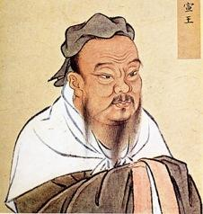
“Since you yourself desire standing then help others achieve it, since you yourself desire success then help others attain it.” (Lunyu 12.2, 6.30)

Please look in your student handbooks at pages regarding discipline. Please list three Legalistic tendencies and three Confucian tendencies.

Confucian | Legalist

Please design a handbook that is based on the Confucian ideas of human nature and government. Each bullet should be a separate section. Be sure to include ideas about:
- How discipline would be conducted
  - Be specific and give examples
  - EXAMPLE: Get in a fight. Consequence: Anger management course to learn how to control anger, as Confucianism promotes education.

- What role principals, deans, guidance counselors, hall monitors and teachers would play?
  - How does each play a role in keeping order within our “society”?
  - Make a separate section for each one, as each plays a different role in the “hierarchy” that is critical to Confucian success.

- Attendance and tardiness
  - How would it be dealt with and how can students “learn” or be trained to conform to society, which is very Confucian?

- How does this help promote student learning within the classroom/ building as a whole?
  - Give a final summary on the effectiveness of your handbook and how it promotes the key values and principles of Confucianism.
  - Any other information you feel is critical to keeping order within our school.

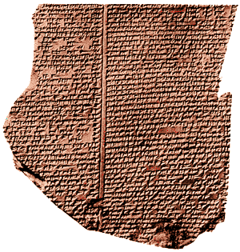
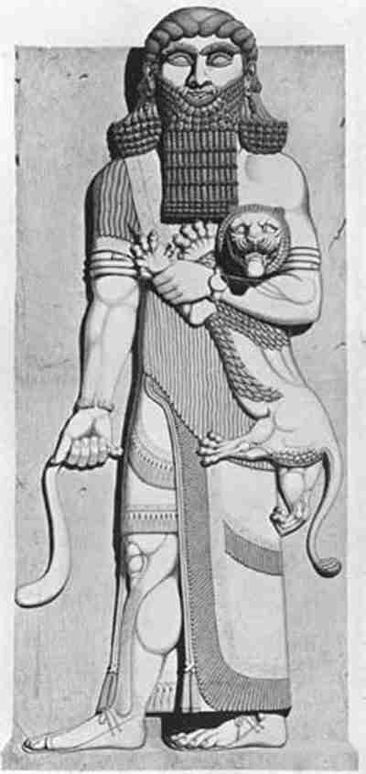

The Epic of Gilgamesh
Gilgamesh was a historical king of Uruk in Babylonia, on the river Euphrates in modern day Iraq; he lived about the date 2700 b.c.e. The civilizations of the Tigris-Euphrates area, among the first civilizations, focus on Gilgamesh and the legends accruing around him to explain them. Many stories and myths were written about Gilgamesh, some of which were written down about 2000 b.c.e. in the Sumerian language on clay tablets which still survive. The Sumerian language, as far as we know, bears no relation to any other human language we know about. These Sumerian Gilgamesh stories were integrated into a longer poem, versions of which survive only in Acadian (the Semitic language, related to Hebrew, spoken by the Babylonians) but also on tablets written in Hurian and Hittite (an Indo-European language, a family of languages which include Greek and English, spoken in Asia Minor). All of the above languages were written in the script known as cuneiform, which means wedge-shaped. The fullest surviving version is derived from twelve stone tablets, in the Acadian language, found in the ruins of the library of Ashwbanipal, king of Assyria, 669-633 b.c.e. at Ninevah. The library was destroyed by the Persians in 612 b.c.e. and all the tablets were damaged. The tablets actually name an author, which is extremely rare in the ancient world, for this particular version of the story the author was Shin-eqi-unninni. You are being introduced to the oldest known human author we can name!

Gilgamesh, who is two-thirds god and one-third man, is the greatest king on earth and the strongest super-human that ever existed. But he is young and oppresses his people harshly. The people call out to their chief god of the city, the sky-god Anu, who creates a wild man, Enkidu, to serve as the subhuman rival to Gilgamesh. Later, when the two fight over what Enkidu sees as abusive authority by Gilgamesh, the two become devoted friends even as Gilgamesh defeats Enkidu.
While on a great adventure together, Enkidu falls ill. In a dream, a great demon drags Enkidu to Hell, a House of Dust, where all dead end up. As he is dying he describes Hell:
The house where the dead dwell in total darkness,
Where they drink dirt and eat stone,
Where they wear feathers like birds,
Where no light ever invades their everlasting darkness,
Where the door and the lock of Hell is coated with thick dust.
When I entered the House of Dust,
On every side the crowns of kings were heaped,
On every side the voices of the kings who wore those crowns,
Who now only served food to the gods Anu and Enlil,
Candy, meat, and water poured from skins.
I saw sitting in this House of Dust a priest and a servant,
I also saw a priest of purification and a priest of ecstasy,
I saw all the priests of the great gods.
There sat Etana and Sumukan,
There sat Ereshkigal, the queen of Hell,
Beletseri, the scribe of Hell, sitting before her:
Beletseri held a tablet and read it to Ereshkigal.
She slowly raised her head when she noticed me,
She pointed at me:
“Who has sent this man?”
At the end of his story, Utnapishtim offers Gilgamesh and chance at immortality. If Gilgamesh can stay awake for six days and seven nights, he too, will become immortal. Gilgamesh accepts these conditions and sits down on the shore, and the instant that he sits down he falls asleep. Utnapishtim tells his wife that all men are liars, that Gilgamesh will deny having fallen asleep, so he asks his wife to bake a loaf of bread every day and lay the loaf at Gilgamesh’s feet. Gilgamesh sleeps without ever waking up for six days and seven nights, at which point Utnapishtim wakes him up. Startled, Gilgamesh says, “I only just dozed off for half a second here.” Utnapishtim points out the loaves of bread, showing their states of decay from the most recent, fresh bread, to the oldest, moldy, stale bread that had been laid at his feet on the very first day. Gilgamesh is distraught:

O whoa!
What do I do now, where do I go now?
Death had devoured my body,
Death dwells in my body,
Wherever I go, wherever I look, there stands Death!

Utnapishtim’s wife convinces the old man to have mercy on Gilgamesh: he offers Gilgamesh in place of immortality a secret plant that will make Gilgamesh young again. The plant is at the bottom of the ocean surrounding the Far Away. Gilgamesh ties stones to his feet, sink to the bottom, and plucks up the magic plant. But he does not use it because he doesn’t trust it; rather he decides to take it back to Uruk and test it out on an old man first, to make sure it works.

Urshanabi takes Gilgamesh across the Waters of Death. Several leagues inland, Gilgamesh and Urshanabi stop to eat and sleep. While they are asleep, a snake slithers up and eats the magic plant (which is why snakes shed their skins) and crawls away. Gilgamesh awakens to find the plant gone; he falls to his knees and weeps:

For whom have I labored?
For whom have I journeyed?
For whom have I suffered?
I have gained absolutely nothing for myself,
I have only profited the snake, the ground lion!

The tale ends with Gilgamesh, at the end of his journey standing before the gates of Uruk, inviting Urshanabi to look around and view the greatness of his city, its high walls, its mason work, and here at the base of its gates, as the foundation of the city walls, a stone of lapis lazuli on which is carved Gilgamesh’s account of his exploits.
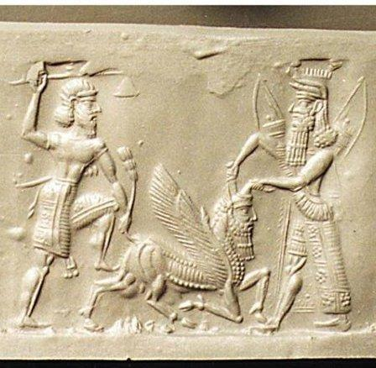

Write a detailed paragraph summary considering the following ideas:

- Who is rewarded in the Sumerian afterlife?
- What does Gilgamesh desire above all else?
- What assumptions can you make about Sumerian life and afterlife
- How is this idea of afterlife similar or different to the Egyptians?
- Support with examples from the reading.

The Book of Leviticus
This book forms part of the Torah and the Bible and defines Jewish law. Because these laws were closely linked to the Jewish concept of God, it differed from the legal codes of other, older civilizations of the Near East. The following selection is from Leviticus Chapter 19, which contains laws that govern actions dealing with laws for ritual practice and daily life.

According to the document, who gave the law to the Jews?  Who are the children of Israel? What is their significance?  What does reap mean?  What does this tell us about the people of Israel?  Why would the law require people to leave some fruits on the vine and wheat in the field?  What is an example of defrauding a person?  What is the purpose of the law stating that a person should ‘love thy neighbor’? | 1] And the LORD spake unto Moses, saying,  [2] Speak unto all the congregation of the children of Israel, and say unto them, Ye shall be holy: for I the LORD your God am holy.  [3] Ye shall fear every man his mother, and his father, and keep my sabbaths: I am the LORD your God…  [9] And when ye reap the harvest of your land, thou shalt not wholly reap the corners of thy field, neither shalt thou gather the gleanings of thy harvest.  [10] And thou shalt not glean thy vineyard, neither shalt thou gather every grape of thy vineyard; thou shalt leave them for the poor and stranger: I am the LORD your God.  [11] Ye shall not steal, neither deal falsely, neither lie one to another…  [13] Thou shalt not defraud thy neighbour, neither rob him: the wages of him that is hired shall not abide with thee all night until the morning.  [14] Thou shalt not curse the deaf, nor put a stumblingblock before the blind, but shalt fear thy God: I am the LORD…  [18] Thou shalt not avenge, nor bear any grudge against the children of thy people, but thou shalt love thy neighbour as thyself: I am the LORD.

The Hebrews and the Foundation of Western Law
Three thousand years ago, the ancient Hebrew people lived in the Near East in an area called Canaan. This ancient people developed the idea of monotheism, the belief in one god. They believed that their god gave them laws to regulate their society, their religious practices, and their relationships with other people.
Conquered by the neo-Babylonians and later by the Romans, the Hebrews eventually became a scattered people, living in many countries under different legal systems. But they continued to develop their own law and tried to follow it even in foreign lands. Their law was based on the Ten Commandments and other sacred writings, which today we find in the Hebrew Bible. In developing their law, they sometimes borrowed legal concepts from other civilizations as well as passing on their own ideas. The Jewish law that developed influenced Roman law, English law, and our own Declaration of Independence and Constitution.

Development of Jewish Law
According to Hebrew teachings, a man named Moses led the Jews out of slavery in Egypt around 1250 B.C. and received the Ten Commandments from God. The Hebrews began writing down the commandments and other legal principles. By the sixth century B.C., they were contained in the Torah and eventually became the first five books of the Bible. The written Torah (“teaching”) provided the ancient Hebrew people with a code of religious and moral laws.
In A.D. 70, after the Romans crushed a Hebrew revolt and destroyed the holy temple in Jerusalem. Faced with religious persecution, many Jews began to leave their homeland, called Palestine by the Romans. Known as Jews, for one region of their homeland called Judea, these people migrated throughout the Middle East, Europe, and other parts of the world.
Some Jewish religious scholars stayed in Palestine while another group of scholars resided in Babylon (in present-day Iraq). For several centuries, scholars in these two centers of Jewish thought debated and interpreted Jewish law. The vast literature that resulted from this effort is called the Talmud. The Talmud mainly focused on how Jewish laws should be applied to everyday life…

Equality
The Torah teaches that God created Adam, the first human, as the father of all peoples. Thus, all humans are born equal and should be treated equally by the law. This is today recognized as a major principle of law.
Although the idea of equality before the law begins with the Torah, the Hebrews did not at first recognize the full meaning of this principle. Like other Middle Eastern peoples in ancient times, the Hebrews did not treat women as the legal equals of men. For example, women were usually not permitted to appear as witnesses in court. Nevertheless, Jewish law still identified many women’s rights and protections.
Like other peoples of the time, the Hebrews also permitted slavery. In many cases, persons bound themselves into slavery to pay debts. Others were thieves ordered by the court into slavery if they could not otherwise pay restitution to their victims. But masters had to release their slaves after six years. They also had to give them a gift to help them start a new life. Jewish law placed so many restrictions on slavery that it had nearly disappeared by the Middle Ages.

The Rule of Law
The Torah does not recognize the idea of kings ruling by divine right. According to tradition, the Hebrew people made Saul their first king in 1030 B.C., when enemy nations threatened their survival. But Saul and the other Hebrew kings that followed him were never considered to be gods or high priests with the power to interpret God’s will.
Hebrew kings, like everyone else, had to obey the Ten Commandments and the other laws of the Torah. The written Torah, not the whims of kings, was considered the law of the land.
The Hebrew concept of majority rule comes from the Torah’s command to “follow the multitude.” The majority decided disputes among scholars on the meaning of God’s laws, the court decisions of judges, and the local acts of Jewish communities.
Since Jews lived under the rule of foreign nations after A.D. 70, they practiced only limited forms of self-government. By the 12th century, however, many countries…

Judaism Reading Questions:

1. Jews believe in one God, the God of _______________, called Adonai in Hebrew.

2. Where is the “promised land” according to the Jews?

3. The Jewish holy book is written in Hebrew and called the TeNaKh. List the three parts included in this holy book:

4. What is the goal of Judaism?

5. What must Jewish people do on the Sabbath?

6. List three of the laws that Jews must abide by according to the Torah:

7. What are the three main sects in Judaism?

8. Why is Jerusalem important for Jews?

